**RAILWAY RESERVATION SYSTEM**

**Manage Train (USE CASE)**

**BRIEF**

Manage Train:

The Admin will Manage the booking, stations, Customers, train, fare. it manages all the information about Booking, Timetable, Fare. Manage train are editing and updating of Records in improved which results in proper resource management of booking data.

The details of the train will be managed by the admin

**USE CASE DIAGRAM**

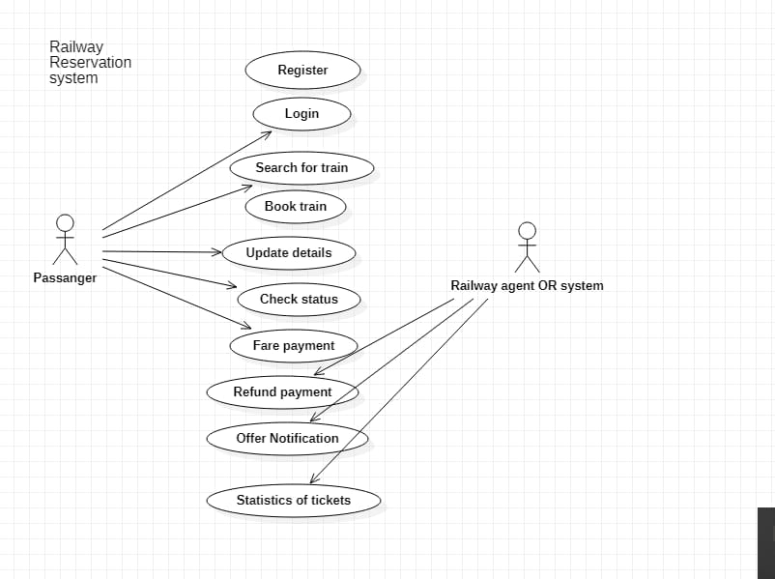

**FULLY DRESSED DIAGRAM**

|  |  |
| --- | --- |
| **USE CASES** | **COMMENT** |
| Use Case Name | Manage Train |
| Scope | Railway Reservation System |
| Level | User Goal |
| Primary Actor | Passenger |
| Stockholders and Interests | Admin: wants to manage the details of the train. i.e. add train, delete train, etc. |
| Preconditions | The user must be registered to the system |
| Success Guarantee | The details of the train will be successfully managed |
| Main Success Scenario | The admin will provide the details of the train |
| Extensions | If the details are not correct user will repeat the steps |
| Special Requirements | Maintainability, Controllable and Usability |

**SSD**

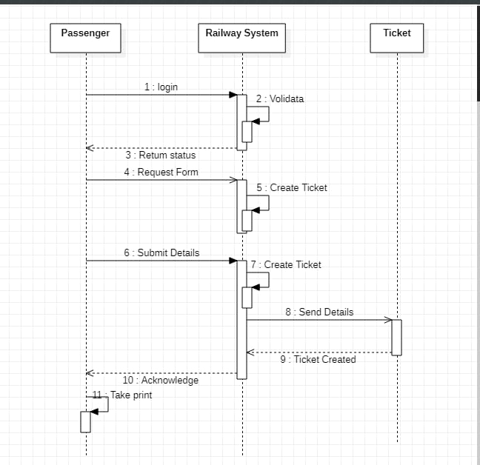

**DOMAIN MODEL**

**OP**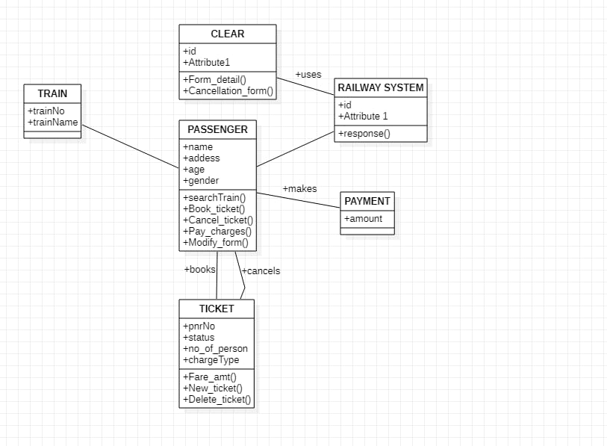

**OPERATION CONTRACTS**